Description of Test | Expected Output | Actual Output | Screenshot | Test pass  /fail
Initial API Fetch | Successfully populates with recipe cards from the API | Populates with recipe cards from the API | 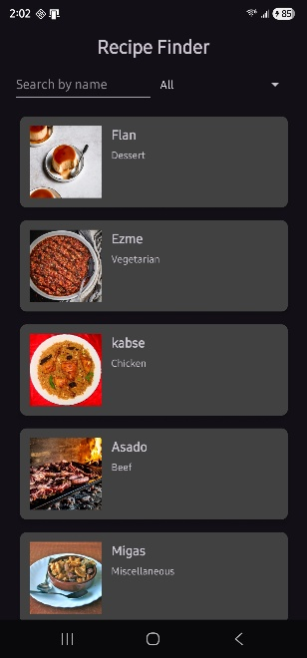 | P
View Binding Integrity | All buttons and text fields trigger correct logic without null pointer crashes | All buttons and text fields trigger correctly | 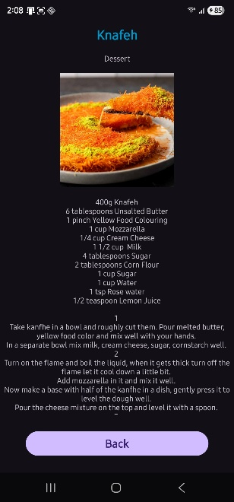 | P
Spinner dropdown | The spinner is visible on the UI | The spinner is visible on the UI | 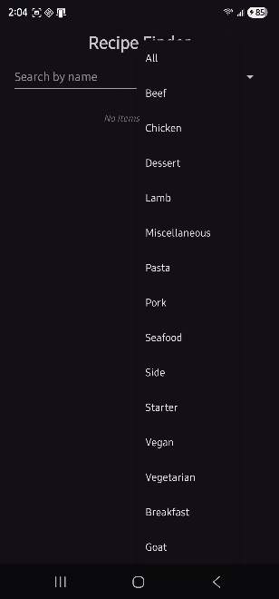
Detail View | Tapping a recipe opens the correct detail fragment with full instructions | correct detail fragment with full instructions appears | 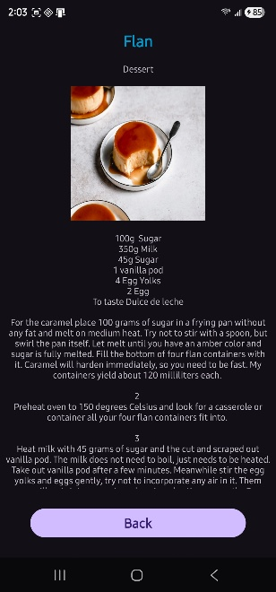 | P
Image Loading | Recipe thumbnails scale and display correctly without distorting the layout | Recipe thumbnails scale and display correctly | 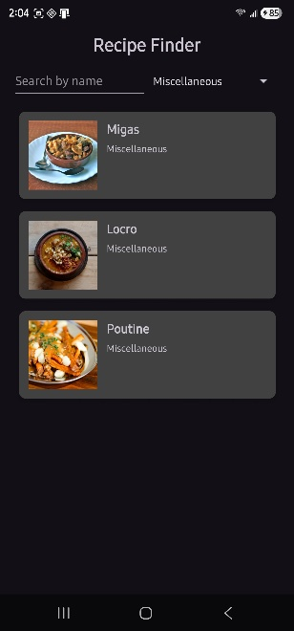 | P
Spinner Boundaries | First recipe in the list category filter correctly | First recipe in the list category filters correctly | 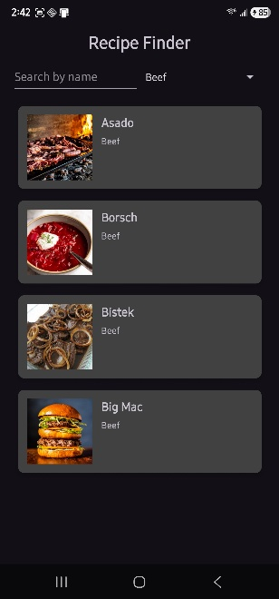 | P
Spinner Boundaries | Last recipe in the list category filter correctly | Last recipe in the list category filters correctly | 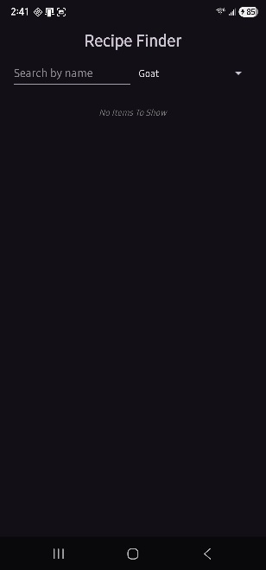 | P
Null Image Handling | Placeholder null image displays for empty image | Placeholder null image | 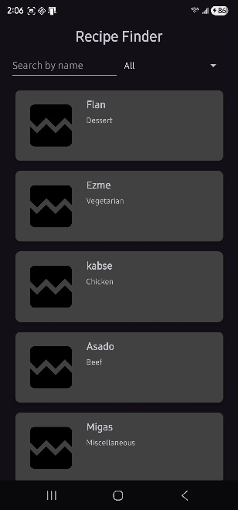 | P
Search bar query | Search results update for queries | Search results update | 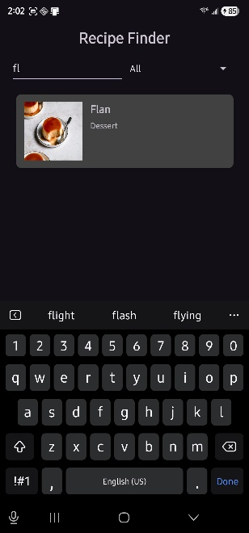 | P
ScrollView | ScrollView allows vertical scrolling | Vertical scrolling | 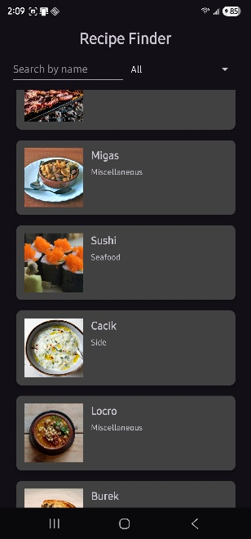 | P
Screen rotate | Data persists without crash on screen rotate | Data persists without crash on screen rotate | 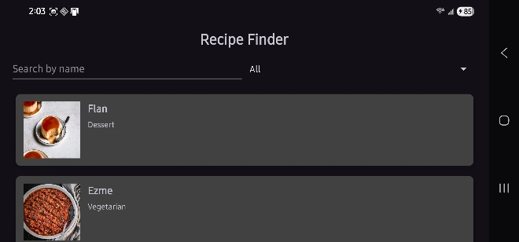 | P
YouTube Handoff | Clicking the video link successfully launches the YouTube app or web browser to the correct URL | Successfully launches the YouTube app | 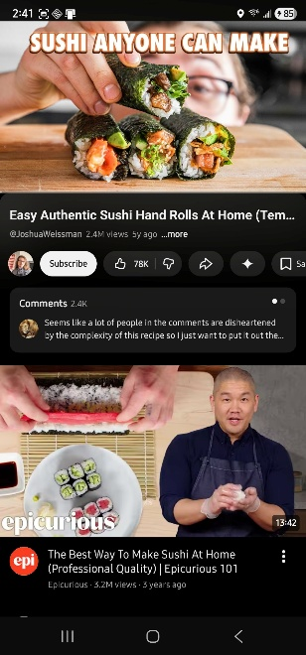 | P
YouTube missing | Recipe without a video shows proper “No Youtube video available” | No video found displays | 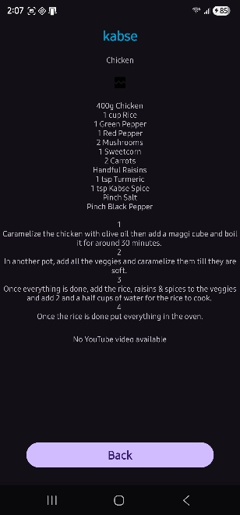 | P
Empty Search/Filter | UI displays "No Items To Show" if a search query has zero results | No Items To Show displays | 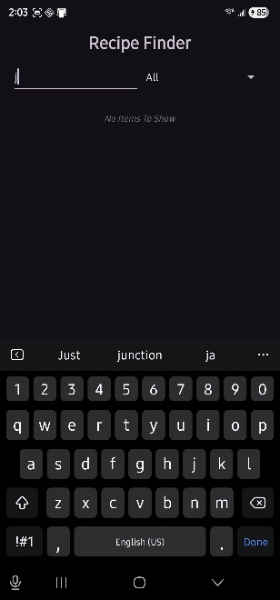 | P

